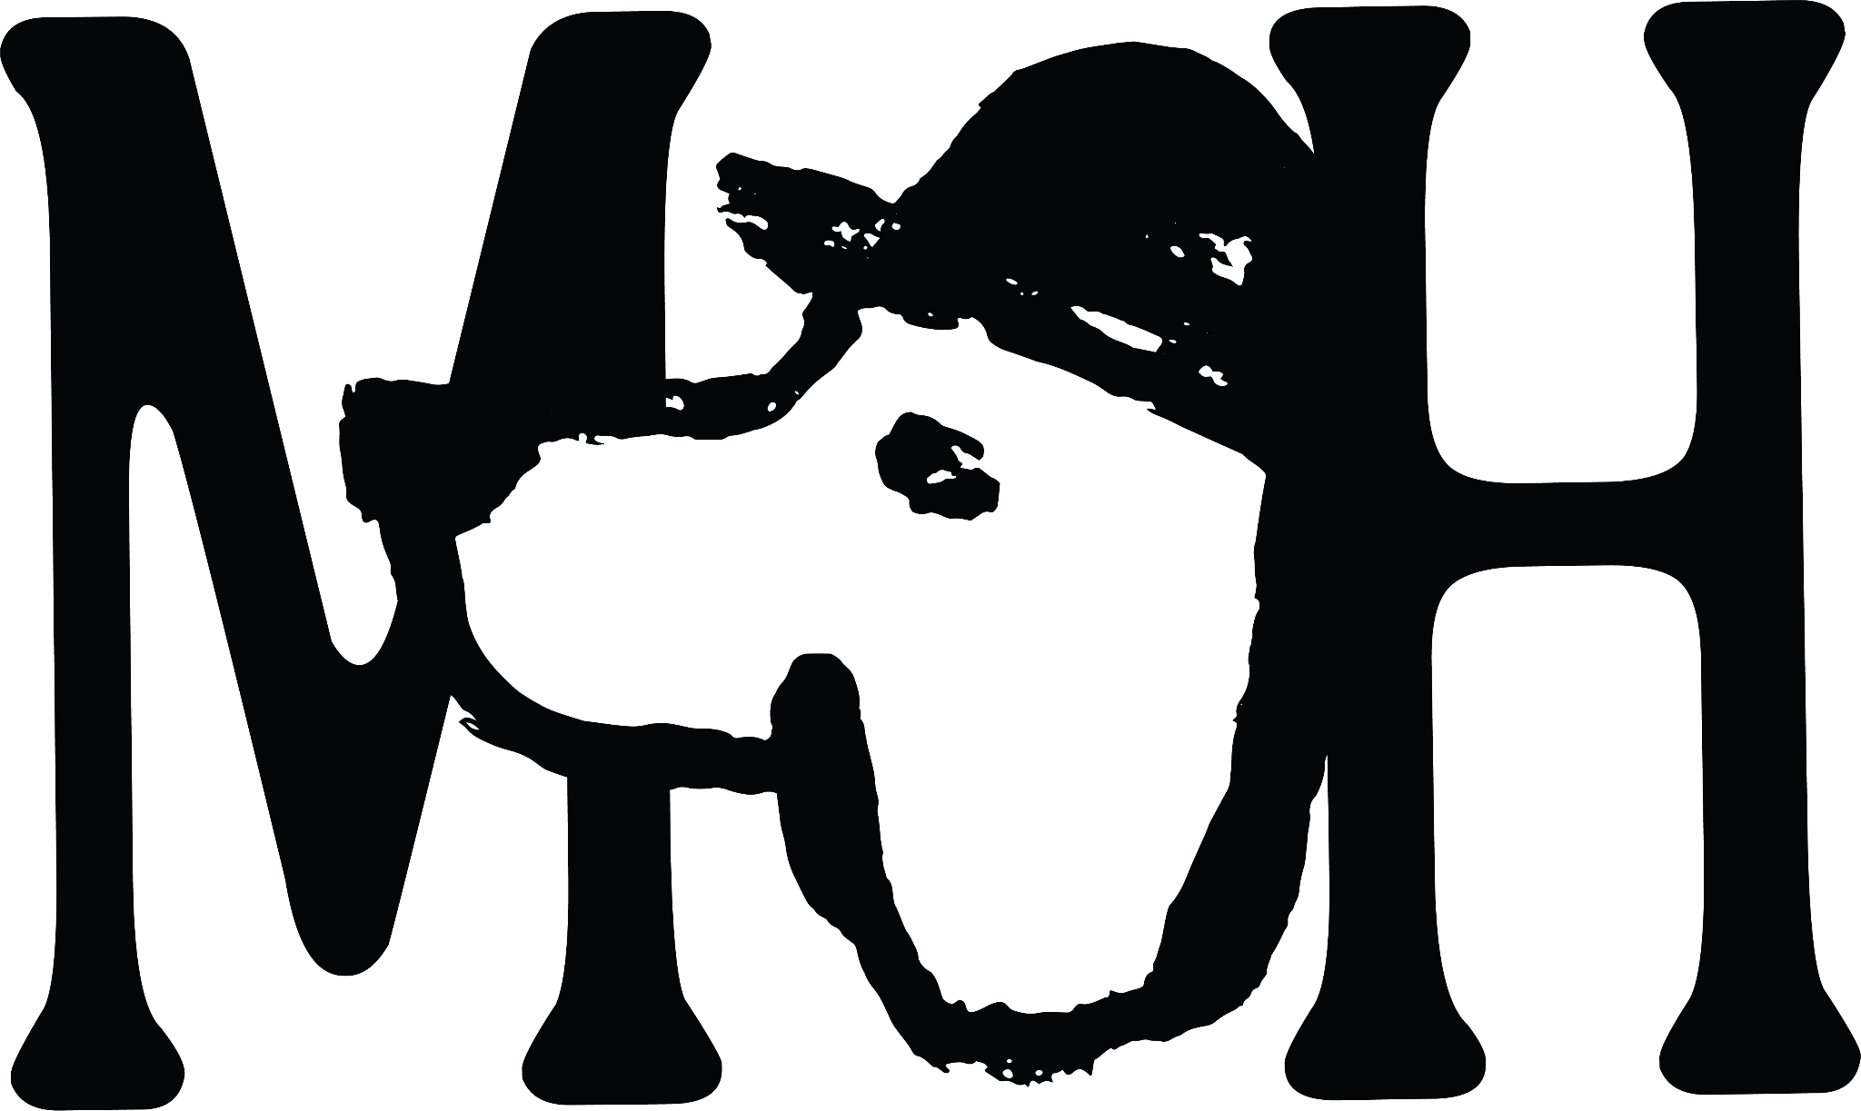

Blood Orange Negroni 12.0 / Bloody Mary 11 / Rum Old Fashioned 10 / Espresso Martini 11
Cynar Spritz 13.5 / Botivo Spritz (non-alc) 6.5 / Elderflower Seedlip Tonic (non-alc) 10.5

Snacks
Nocellara olives (Sulphites) 4.5
Hoxton Sourdough & salted butter (Gluten, Dairy) 4.5
Scotch egg & brown sauce (Gluten, Egg, Dairy, Mustard, Sulphites) 7.0
Wintershall lamb ribs with garlic aioli (Sulphites, Egg) 7.0

Starters
Wookey Hole cheddar & Hogs Back ale soup, marmite rarebit and pickled silverskin onion 9.5
(Allium, Gluten, Dairy, Sulphites, Fish, Mustard, Celery)
Goldie’s beetroot, candied walnuts, Rosary goats cheese & bitter leaves
(Egg, Dairy, Nut, Sulphites) 10.0
Loxwood venison tartare, plum ketchup & Toast (Gluten, Mustard, Sulphites) 13.0
Kennet crayfish & smoked salmon cocktail with all the usual suspects
(Celery, Gluten, Crustacean, Egg, Fish, Dairy, Mustard, Sulphites) 14.0

Mains
Pan roast Wintershall Ox liver, glazed shallots, colcannon mash & gravy (Allium, Dairy) 19.0
Penny bun, Jerusalem artichoke & leek tart with a Sussex charmer sauce
(Gluten, Egg, Dairy, Sulphites) 19.5

Mixed Leaf Salad 6.5 (Allium, Sulphites) / Buttered Cabbage 6.0 (Dairy)

Roast Platters To Share min, 2 people
Roast loin of pork from our farm, bramley apple sauce & crispy pork belly 25pp
Trenchmore farm Sussex x Wagyu roast beef & horseradish cream 27.0 pp

All roasts are served with bubble & squeak croquettes, duck fat roast potatoes, buttered greens, roast root vegetables, yorkshires and proper gravy.
(Gluten, Egg, Dairy)

Pudding
Jamaican ginger sticky toffee pudding & whisky toffee sauce (Gluten, Egg, Milk) 8.5
Banana split, chocolate mousse with almonds & sprinkles (Egg, Milk, Nuts) 9.5
Sussex Stilton with pear & lavosh (Gluten, Egg, Milk, Dairy, Sulphites) 9.0

Meet Our Makers

At the Merry Harriers we aim to source our produce as locally and as ethically as possible.
We are lucky enough to be surrounded by some of the UK’s best producers in the heart of the Surrey Hills
Here are some of them:

Wintershall Valley Farm: A stone's throw from the Merry Harriers, Sam’s Mum Henrietta supplies the pub with pork, beef and lamb year-round from her Wintershall Valley Farm. Henrietta lovingly tends to a drove of Oxford Sandies, reared for their lean pork, as well as an impressive herd of Sussex Cattle, Wagyu and Sussex Cross cows. She boasts the largest flock of Herdwick sheep in the South of England. Sam butchers all our meat in-house minimising waste and using as much of the animal as possible in his menus.
Kennet Crayfish: Our crayfish is trapped by hand exclusively from the gin-clear, nutrient-rich waters of the River Kennet. The river is mainly groundwater-fed from a Cretaceous chalk aquifer, granting the crayfish a unique and utterly delicious flavour. Our supplier, Kennet Crayfish, are on a mission to sustain British waterways for future generations by increasing awareness of the plight of our rivers and increasing the popularity of crayfish.
Venison: Albie Lyons has been a deerstalker for 55 years. He is a strong believer that, “if you stop doing things, you stop working”. Believe it or not he is 86 years young! It is a hobby and a job he enjoys working across Sussex at High Beeches, Andcross and Billingshurst. He culls deer to keep numbers down for conservation purposes and to counter overpopulation.
Goldie’s Greens: The brainchild of Sam’s sister Goldie, Goldie’s Greens are the (literal) fruits from the kitchen garden at nearby restaurant Hilltop Kitchen. Using her growing experience at Green Michelin-starred farm and restaurant, Heckfield Place, Goldie lovingly built and sowed the raised beds in February 2023. By late spring, the garden had flourished, and its harvest has continually supplied Hilltop Kitchen with gorgeous fruit and vegetables throughout the summer and autumn. Goldie focusses on perennial herbs, enabling a rotational crop that allows chefs to have their pick of the best all year round.
Greyfriars Vineyard: Located on the sunny south-facing chalk slopes of the Hog’s Back at Puttenham, Greyfriars produce a variety of spectacular English sparkling and still wines. The unique soil conditions, aspect and climate contribute to every bottle’s unique (and in many cases, award-winning) constitution. A marriage of traditional technique and modern machinery, the vineyard is paving the way for winemakers in the Surrey North Downs.
Village Spirit Collective: The closest of all our suppliers (quite literally our next-door neighbours), the Village Spirit Collective is owned and run by Ian Cox who left a city job in favour of a work-life balance. Ian produces everything by-hand himself in his micro-batch distillery, from crushing the botanicals and distilling, to labelling and distribution.
Ripping Yarns Distillery Surrey’s first dedicated rum distillery. The Ripping Yarns team make award-winning premium rums completely from scratch in the Surrey Hills using only the finest cane sugar molasses. They are a family-run business and are across the entire Rum-making process, from fermentation to bottling - “molasses to glass”, as they like to say.

For more information about any of our partners, please ask one of our team.

Eat well. Eat local. Eat seasonal.

