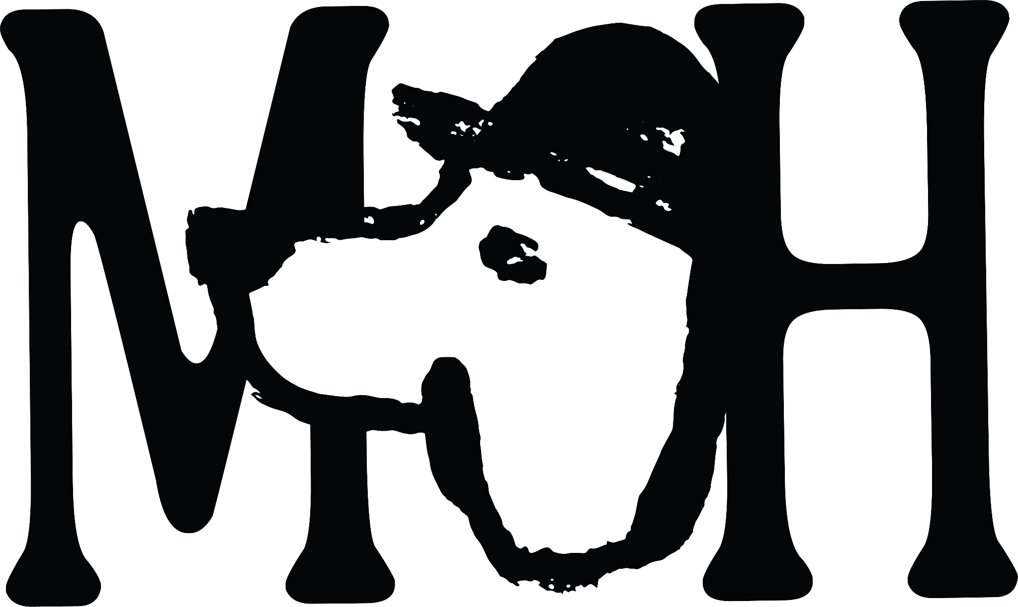

Bar Snacks
Fairfields farm crisps 2
Pork scratchings 2
Monster munch (pickled onion obvs..) 2
Crisps & a pickled egg 3.5
Bombay mix 2
Mixed nuts 2
Nocellara olives 4.5
•
Hoxton Sourdough & salted butter 4.5
Hashbrown bites, Philadelphia & sweet chilli sauce 5.5
Bubble & squeak croquettes with tomato relish 6.5
Scotch egg & brown sauce 7.0
Wintershall lamb ribs with roast garlic mayo 7.0

Batch Negroni
Our infused big batch Negroni, this time made with blood orange and Cocchi di Torino Vermouth for a smooth finish.
12

Rum Old Fashioned
Using the only British made rum from Ripping Yarns we've crafted a beautiful modern take on an old classic.
10

Espresso Martini
Chimney Fire coffee, Mr Black and the smooth Black Cow Vodka makes this the perfect pre/post dinner sipper.
11

Cynar Spritz
The bitter bite of artichoke liqueur meets the crispness of Greyfriars sparkling wine, creating a harmony of contrasts.
13.5

Botivo Spritz (non-alc)
Botivo is a deeply refreshing, aperitif inspired drink with bittersweet, herbal and citrus notes.
6.5

Elderflower Seedlip Tonic (non-alc)
Our house non-alc G&T elevated by infusing seedleep with cucumber and elderflower to create a refreshing, palette cleansing refresher fit for any occasion.
10.5

Kombucha 5 / Dalston Rhubarb 4 / Ginger Beer 3.5

